
Year 8 History Name_______________________
FEUDAL JAPAN ASSESSMENT
(Comparison Task) Target_______/45
Total: 45

Answer ALL questions on this paper.

1. Japan ...
a) .. is the largest country in Europe
b) .. is an archipelago in East Asia
c) ... shares a border with Indonesia and Thailand
d) ... is another name for China

2. What were the two most influential belief systems in Japan?
a) Christianity and Atheism
b) Islam and Buddhism
c) Christianity and Shinto
d) Shinto and Buddhism

3. What was 'seppuku'?
a) A popular form of sushi
b) The military leader of all daimyo
c) An honourable way for a samurai to die through cutting open his stomach
d) The famous rebellion when peasants attacked the samurai.

4. What was the warrior code or rules that a samurai had to follow called?
a) Bushido
b) Kabuki
c) Tokugawa
d) Edo

5. Under the Alternate Attendance policy in the Tokugawa period the Daimyo had to travel to the capital city every second year. Why did the Shogun make this rule?
a) So that he could easily communicate with the, whole country.
b) To make the daimyo poor and to-keep their family hostage
c) To force the daimyo to travel and appreciate all of Japan
d) To Keep him company because he was lonely

6. What was the name of the old-fashioned, muzzle-loaded guns brought to Japan by the Portuguese?
a) Musket
b) Tokugawa
c) AK47
d) Uzi 9mm

7. Daimyo were carried in boxes with couches called:
a) couchettes
b) stretchers
c) katanas
d) palanquins

8. What were the masterless samurai with no daimyo called?
a) Outcasts
b) Chanin
c) Ronin
d) Bushi

END OF MULTIPLE CHOICE

SECTION 2 Japanese Society /18 marks
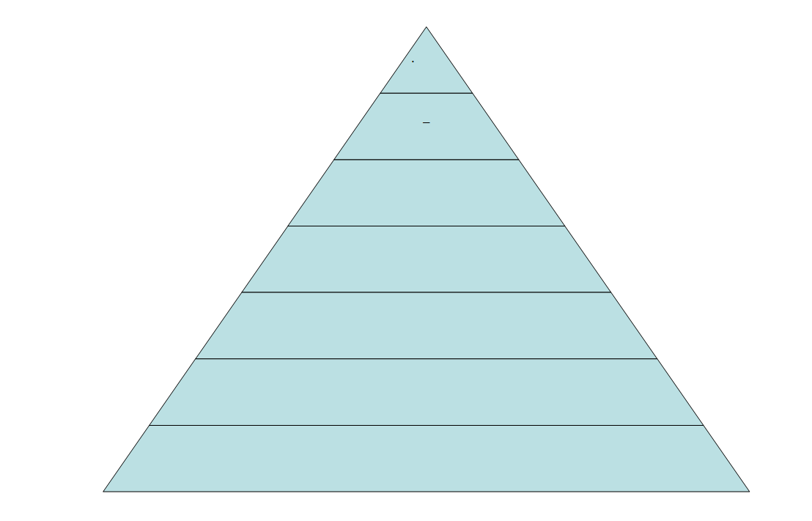
9. Label the social pyramid below with the classes of feudal Japanese society from the box under the diagram. Then add a brief explanation of the meaning of the word and/or what they did. (14 marks)

Daimyo | Samurai | Emperor | Peasants | Shogun | Merchants | Artisans

(Refer to the Social Pyramid for Questions 10, 11 and 12)
10. Which person had the most real power in feudal Japan? ________________ (1 mark)
11. Which group made up 90% of the population? _____________________________ (1 mark)
12. How is this Japanese social pyramid different from the feudal power pyramid from Europe?
Why is that so? (2 marks)
__________________________________________________________________________________________________________________________________________________________________________________________________________________________________________________________________________________________________________________________________________________________________________________________________________________________
13. Use the Venn diagram below to show the similarities (5) and differences (2 x 5) between Medieval Knights and Japanese Samurai Warriors. ( 5 statements for each "area")

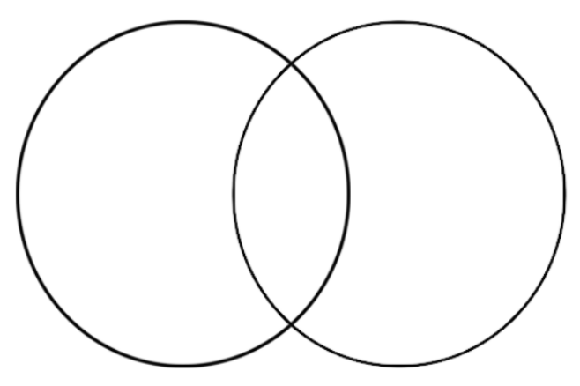

END OF T

END OF ASSESSMENT

